INVITE EMAIL/TEXT TEMPLATES / STRONGER THAN STRESS

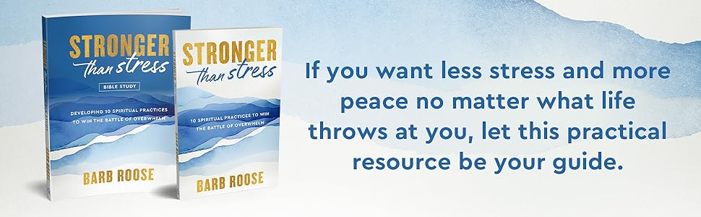

Email Template #1
(You can use this as an email communication in your church newsletter. You can edit or adjust this email to meet your specific needs. NOTE: If you want to create a video, this email can also be used as a video script as well for social media videos or an announcement during church)

Dear

Join us for the Stronger Than Stress Bible study, but popular Bible study author, Barb Roose. We’re hosting this six-week Bible study beginning (insert date).

Everyone experiences seasons of stress, but you are not condemned to a lifetime of overwhelm. Stronger than Stress offers 10 spiritual practices to help you overcome daily overwhelm with God's peace and strength. Learn from the life and teachings of the apostle Paul as you dive deeper into just how to make chronic stress and overwhelm a thing of the past by applying each practice to your life.

This interactive Bible study helps you:

· Focus on God's big picture that enables you to see beyond your stress
· Study 10 spiritual practices that create space for you to connect with God
· Learn your stress triggers and effective, Scripture-based tools to experience peace
· Win your battle of daily overwhelm so that you can live strong in your purpose and passion

You can sign up for this Bible study by (insert instructions). You can purchase the Stronger Than Stress Bible Study at Amazon, Barnes & Noble, Christianbook.com, Target, Wal-Mart, Cokesbury and other online retailers.

We’d love for you to join us for this powerful Bible study!

Email Template #2
Did you know that 49% of American adults report feeling substantial stress each day and almost 25% of people aren’t able to function. Perhaps, you can relate to these statistics more than you’d like to admit.

However, the good news is that you don’t have to live in a constant state of stress. God has given you everything that you need to break the stress cycle and win the battle of overwhelm by learning how to live in His unlimited peace and strength.

Join us for our next Bible study starting on (Date). Our study will be Stronger Than Stress: 10 Spiritual Practices to Win the Battle of Overwhelm by author Barb Roose. This six-week Bible study includes an in-depth Bible study and practical tools to equip you to live with less stress and more of God’s peace, no matter your difficult daily circumstances.

You can sign up now!

Invite Text Messages
I’m kicking off a NEW Bible study called Stronger Than Stress by Barb Roose. I’d love for you to join in so that we can learn together and encourage each other. Check out the link on the study and let me know if you’re interested. https://bit.ly/3VcVyiX

Hey! Since everyone’s been talking about feeling so stressed, I decided that I’d put together a Bible study for us. There’s a new Bible study called Stronger Than Stress by Barb Roose and it’s a six-week study. Check out the link and let me know if you’re interested. https://bit.ly/3VcVyiX

It’s almost time to kick off our Fall Bible study! We’re doing the Stronger Than Stress Bible study by Barb Roose. We’d love to have you join us! Check out the link on the study and let me know if you’ll join us. https://bit.ly/3VcVyiX

ZOOM SPECIFIC INVITE: Okay, I’m trying something new! I’m going to host a Bible study on Zoom and wondered if you’d like to come? I’m going to do the Stronger Than Stress study by Barb Roose. It’s a six-week study and I’d love to have you join us!

ONE WEEK REMINDER TEXT - A friendly reminder! Just wanted to drop a note that our Stronger Than Stress Bible study begins NEXT WEEK! I’m so excited to see you! If you need to order your study, you can use this link: https://bit.ly/3VcVyiX

